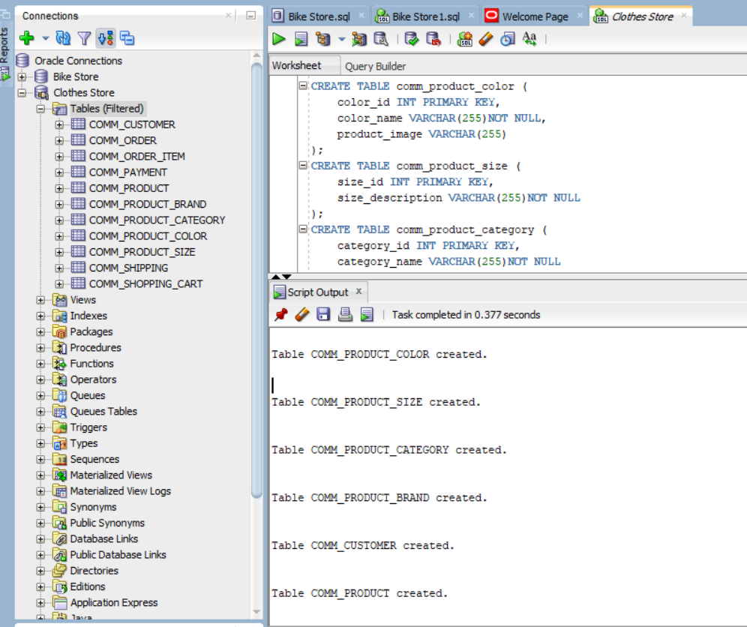

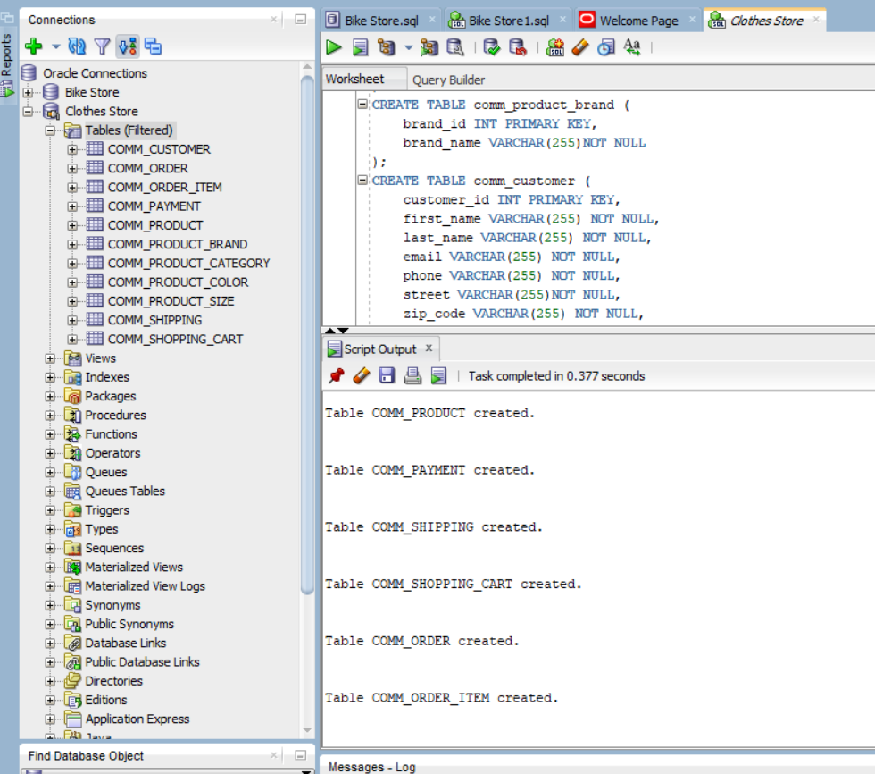

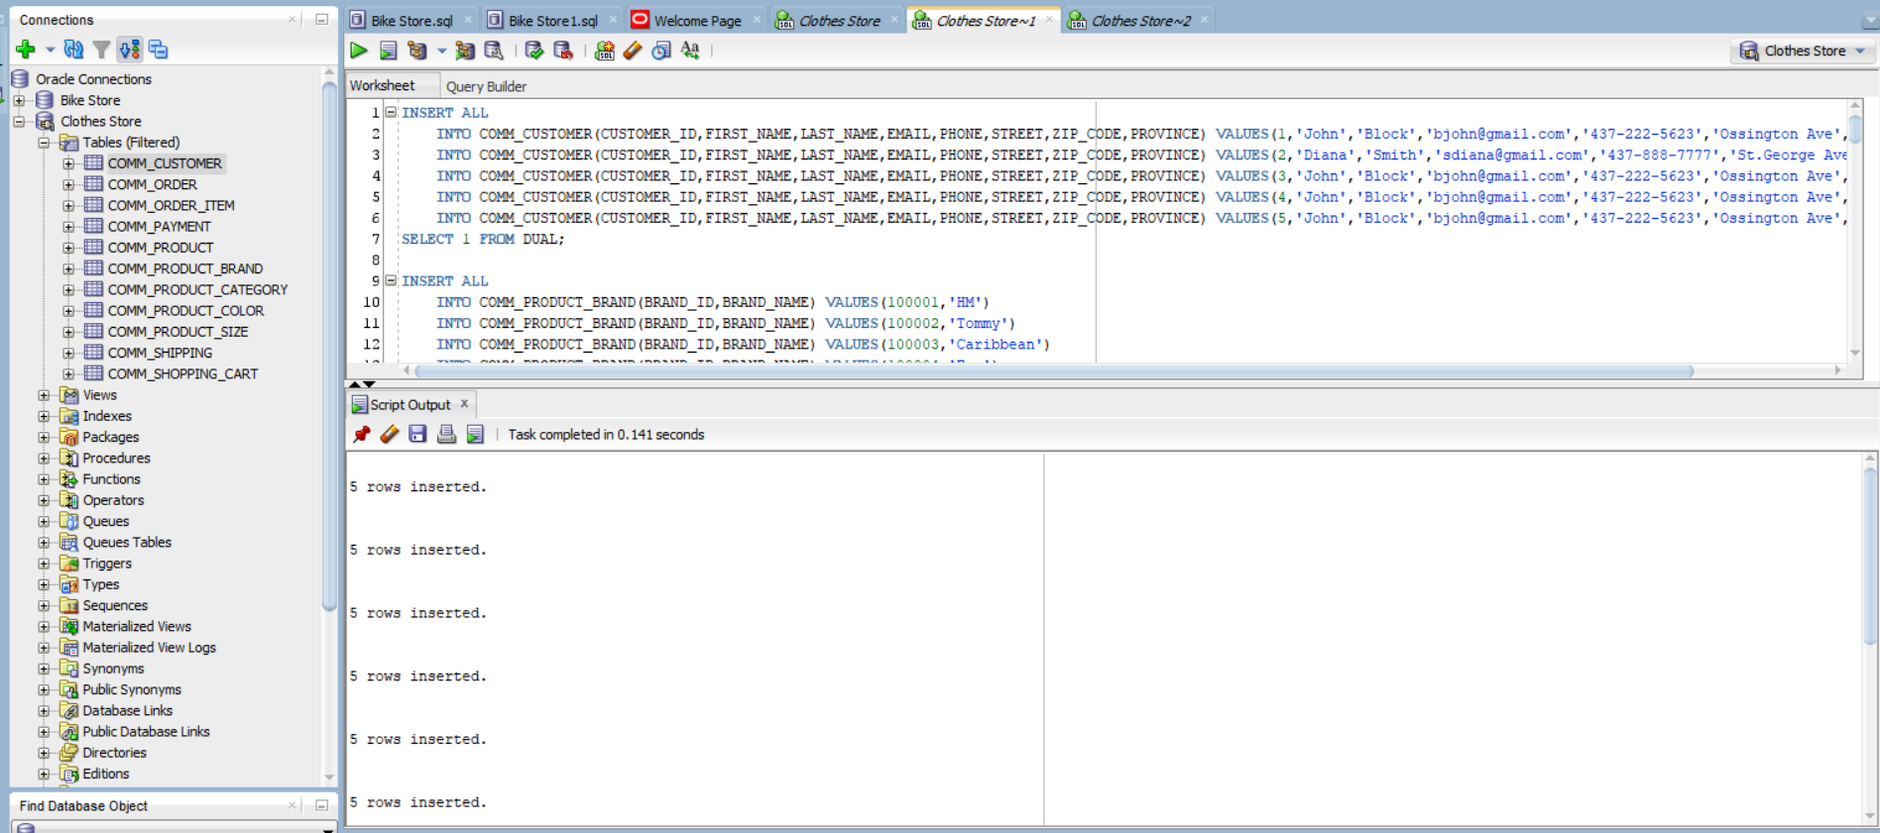

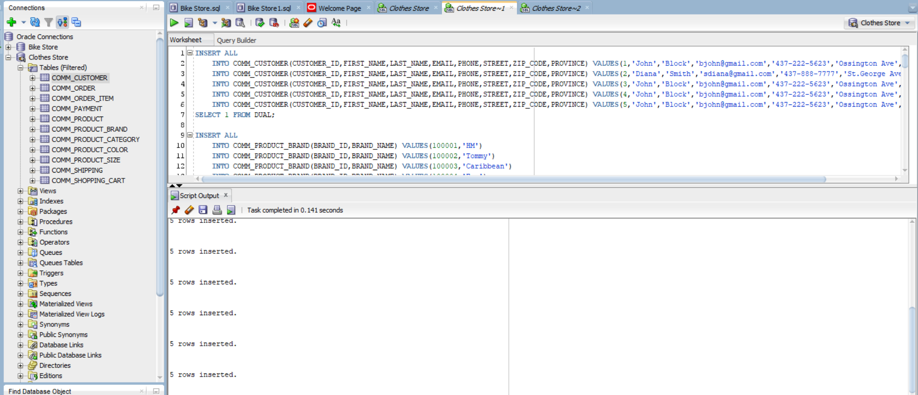

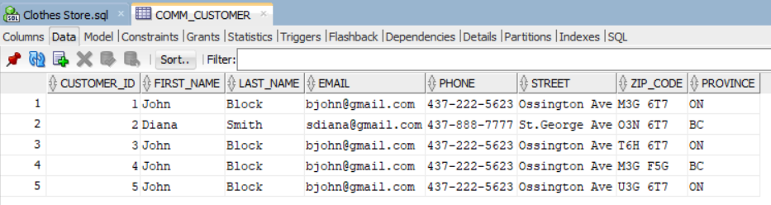

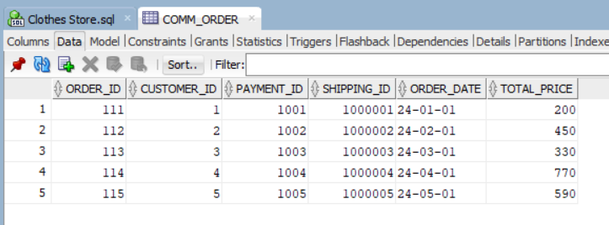

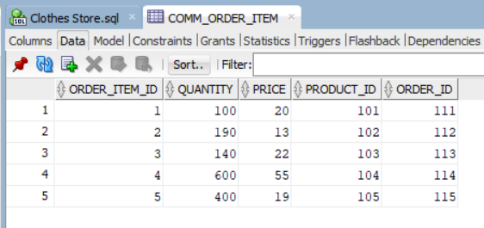

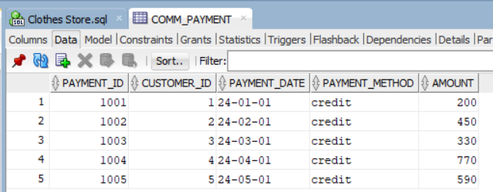

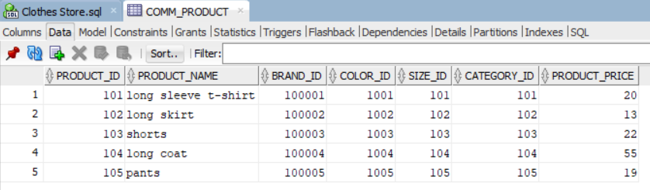

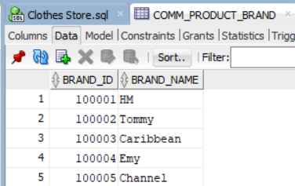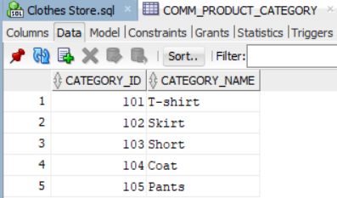

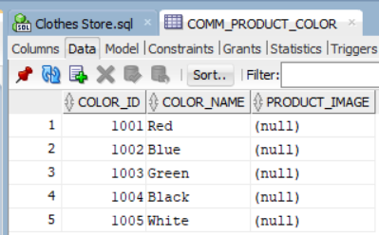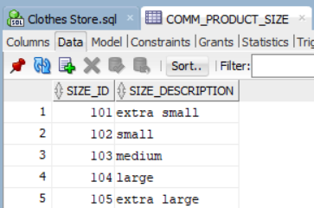

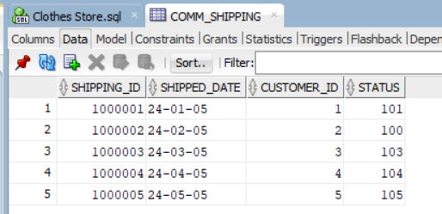

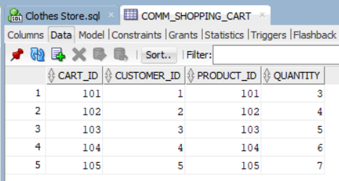

Command:

-- Create table

CREATE TABLE comm_product_color (

color_id INT PRIMARY KEY,

color_name VARCHAR(255)NOT NULL,

product_image VARCHAR(255)

);

CREATE TABLE comm_product_size (

size_id INT PRIMARY KEY,

size_description VARCHAR(255)NOT NULL

);

CREATE TABLE comm_product_category (

category_id INT PRIMARY KEY,

category_name VARCHAR(255)NOT NULL

);

CREATE TABLE comm_product_brand (

brand_id INT PRIMARY KEY,

brand_name VARCHAR(255)NOT NULL

);

CREATE TABLE comm_customer (

customer_id INT PRIMARY KEY,

first_name VARCHAR(255) NOT NULL,

last_name VARCHAR(255) NOT NULL,

email VARCHAR(255) NOT NULL,

phone VARCHAR(255) NOT NULL,

street VARCHAR(255)NOT NULL,

zip_code VARCHAR(255) NOT NULL,

province VARCHAR(255) NOT NULL

);

CREATE TABLE comm_product (

product_id INT PRIMARY KEY,

product_name VARCHAR(255),

brand_id INT NOT NULL,

color_id INT NOT NULL,

size_id INT NOT NULL,

category_id INT NOT NULL,

product_price DECIMAL(10,2),

FOREIGN KEY (brand_id) REFERENCES comm_product_brand(brand_id),

FOREIGN KEY (color_id) REFERENCES comm_product_color(color_id),

FOREIGN KEY (size_id) REFERENCES comm_product_size(size_id),

FOREIGN KEY (category_id) REFERENCES comm_product_category(category_id)

);

CREATE TABLE comm_payment (

payment_id INT PRIMARY KEY,

customer_id INT,

payment_date DATE,

payment_method VARCHAR(255)NOT NULL,

amount DECIMAL(10,2) NOT NULL,

FOREIGN KEY (customer_id) REFERENCES comm_customer(customer_id)

);

CREATE TABLE comm_shipping (

shipping_id INT PRIMARY KEY,

shipped_date DATE,

customer_id INT,

status INT NOT NULL,

-- (1:processing, 2:rejected, 3:shipped)

FOREIGN KEY (customer_id) REFERENCES comm_customer(customer_id)

);

CREATE TABLE comm_shopping_cart (

cart_id INT PRIMARY KEY,

customer_id INT,

product_id INT,

quantity INT,

FOREIGN KEY (customer_id) REFERENCES comm_customer(customer_id),

FOREIGN KEY ( product_id) REFERENCES comm_product(product_id)

);

CREATE TABLE comm_order (

order_id INT PRIMARY KEY,

customer_id INT,

payment_id INT,

shipping_id INT,

order_date DATE,

total_price DECIMAL(10,2),

FOREIGN KEY (customer_id) REFERENCES comm_customer(customer_id),

FOREIGN KEY (payment_id) REFERENCES comm_payment(payment_id),

FOREIGN KEY (shipping_id) REFERENCES comm_shipping(shipping_id)

);

CREATE TABLE comm_order_item (

order_item_id INT,

quantity INT,

price DECIMAL(10,2),

product_id INT,

order_id INT,

PRIMARY KEY(order_item_id,order_id),

FOREIGN KEY ( product_id) REFERENCES comm_product(product_id),

FOREIGN KEY ( order_id) REFERENCES comm_order(order_id)

);

-- Insert records

INSERT ALL

INTO COMM_CUSTOMER(CUSTOMER_ID,FIRST_NAME,LAST_NAME,EMAIL,PHONE,STREET,ZIP_CODE,PROVINCE) VALUES(1,'John','Block','bjohn@gmail.com','437-222-5623','Ossington Ave','M3G 6T7','ON')

INTO COMM_CUSTOMER(CUSTOMER_ID,FIRST_NAME,LAST_NAME,EMAIL,PHONE,STREET,ZIP_CODE,PROVINCE) VALUES(2,'Diana','Smith','sdiana@gmail.com','437-888-7777','St.George Ave','O3N 6T7','BC')

INTO COMM_CUSTOMER(CUSTOMER_ID,FIRST_NAME,LAST_NAME,EMAIL,PHONE,STREET,ZIP_CODE,PROVINCE) VALUES(3,'John','Block','bjohn@gmail.com','437-222-5623','Ossington Ave','T6H 6T7','ON')

INTO COMM_CUSTOMER(CUSTOMER_ID,FIRST_NAME,LAST_NAME,EMAIL,PHONE,STREET,ZIP_CODE,PROVINCE) VALUES(4,'John','Block','bjohn@gmail.com','437-222-5623','Ossington Ave','M3G F5G','BC')

INTO COMM_CUSTOMER(CUSTOMER_ID,FIRST_NAME,LAST_NAME,EMAIL,PHONE,STREET,ZIP_CODE,PROVINCE) VALUES(5,'John','Block','bjohn@gmail.com','437-222-5623','Ossington Ave','U3G 6T7','ON')

SELECT 1 FROM DUAL;

INSERT ALL

INTO COMM_PRODUCT_BRAND(BRAND_ID,BRAND_NAME) VALUES(100001,'HM')

INTO COMM_PRODUCT_BRAND(BRAND_ID,BRAND_NAME) VALUES(100002,'Tommy')

INTO COMM_PRODUCT_BRAND(BRAND_ID,BRAND_NAME) VALUES(100003,'Caribbean')

INTO COMM_PRODUCT_BRAND(BRAND_ID,BRAND_NAME) VALUES(100004,'Emy')

INTO COMM_PRODUCT_BRAND(BRAND_ID,BRAND_NAME) VALUES(100005,'Channel')

SELECT 1 FROM DUAL;

INSERT ALL

INTO COMM_PRODUCT_CATEGORY(CATEGORY_ID,CATEGORY_NAME) VALUES(101,'T-shirt')

INTO COMM_PRODUCT_CATEGORY(CATEGORY_ID,CATEGORY_NAME) VALUES(102,'Skirt')

INTO COMM_PRODUCT_CATEGORY(CATEGORY_ID,CATEGORY_NAME) VALUES(103,'Short')

INTO COMM_PRODUCT_CATEGORY(CATEGORY_ID,CATEGORY_NAME) VALUES(104,'Coat')

INTO COMM_PRODUCT_CATEGORY(CATEGORY_ID,CATEGORY_NAME) VALUES(105,'Pants')

SELECT 1 FROM DUAL;

INSERT ALL

INTO COMM_PRODUCT_COLOR(COLOR_ID,COLOR_NAME,PRODUCT_IMAGE) VALUES(1001,'Red','')

INTO COMM_PRODUCT_COLOR(COLOR_ID,COLOR_NAME,PRODUCT_IMAGE) VALUES(1002,'Blue','')

INTO COMM_PRODUCT_COLOR(COLOR_ID,COLOR_NAME,PRODUCT_IMAGE) VALUES(1003,'Green','')

INTO COMM_PRODUCT_COLOR(COLOR_ID,COLOR_NAME,PRODUCT_IMAGE) VALUES(1004,'Black','')

INTO COMM_PRODUCT_COLOR(COLOR_ID,COLOR_NAME,PRODUCT_IMAGE) VALUES(1005,'White','')

SELECT 1 FROM DUAL;

INSERT ALL

INTO COMM_PRODUCT_SIZE(SIZE_ID,SIZE_DESCRIPTION) VALUES(101,'extra small')

INTO COMM_PRODUCT_SIZE(SIZE_ID,SIZE_DESCRIPTION) VALUES(102,'small')

INTO COMM_PRODUCT_SIZE(SIZE_ID,SIZE_DESCRIPTION) VALUES(103,'medium')

INTO COMM_PRODUCT_SIZE(SIZE_ID,SIZE_DESCRIPTION) VALUES(104,'large')

INTO COMM_PRODUCT_SIZE(SIZE_ID,SIZE_DESCRIPTION) VALUES(105,'extra large')

SELECT 1 FROM DUAL;

INSERT ALL

INTO COMM_PRODUCT(PRODUCT_ID,PRODUCT_NAME,BRAND_ID,COLOR_ID,SIZE_ID,CATEGORY_ID,PRODUCT_PRICE) VALUES(101,'long sleeve t-shirt',100001,1001,101,101,20)

INTO COMM_PRODUCT(PRODUCT_ID,PRODUCT_NAME,BRAND_ID,COLOR_ID,SIZE_ID,CATEGORY_ID,PRODUCT_PRICE) VALUES(102,'long skirt',100002,1002,102,102,13)

INTO COMM_PRODUCT(PRODUCT_ID,PRODUCT_NAME,BRAND_ID,COLOR_ID,SIZE_ID,CATEGORY_ID,PRODUCT_PRICE) VALUES(103,'shorts',100003,1003,103,103,22)

INTO COMM_PRODUCT(PRODUCT_ID,PRODUCT_NAME,BRAND_ID,COLOR_ID,SIZE_ID,CATEGORY_ID,PRODUCT_PRICE) VALUES(104,'long coat',100004,1004,104,104,55)

INTO COMM_PRODUCT(PRODUCT_ID,PRODUCT_NAME,BRAND_ID,COLOR_ID,SIZE_ID,CATEGORY_ID,PRODUCT_PRICE) VALUES(105,'pants',100005,1005,105,105,19)

SELECT 1 FROM DUAL;

INSERT ALL

INTO COMM_SHIPPING(SHIPPING_ID,SHIPPED_DATE,CUSTOMER_ID,STATUS) VALUES(1000001,'2024-01-05',1,101)

INTO COMM_SHIPPING(SHIPPING_ID,SHIPPED_DATE,CUSTOMER_ID,STATUS) VALUES(1000002,'2024-02-05',2,100)

INTO COMM_SHIPPING(SHIPPING_ID,SHIPPED_DATE,CUSTOMER_ID,STATUS) VALUES(1000003,'2024-03-05',3,103)

INTO COMM_SHIPPING(SHIPPING_ID,SHIPPED_DATE,CUSTOMER_ID,STATUS) VALUES(1000004,'2024-04-05',4,104)

INTO COMM_SHIPPING(SHIPPING_ID,SHIPPED_DATE,CUSTOMER_ID,STATUS) VALUES(1000005,'2024-05-05',5,105)

SELECT 1 FROM DUAL;

INSERT ALL

INTO COMM_PAYMENT(PAYMENT_ID,CUSTOMER_ID,PAYMENT_DATE,PAYMENT_METHOD,AMOUNT) VALUES(1001,1,'24-JAN-01','credit',200)

INTO COMM_PAYMENT(PAYMENT_ID,CUSTOMER_ID,PAYMENT_DATE,PAYMENT_METHOD,AMOUNT) VALUES(1002,2,'24-FEB-01','credit',450)

INTO COMM_PAYMENT(PAYMENT_ID,CUSTOMER_ID,PAYMENT_DATE,PAYMENT_METHOD,AMOUNT) VALUES(1003,3,'24-MAR-01','credit',330)

INTO COMM_PAYMENT(PAYMENT_ID,CUSTOMER_ID,PAYMENT_DATE,PAYMENT_METHOD,AMOUNT) VALUES(1004,4,'24-APR-01','credit',770)

INTO COMM_PAYMENT(PAYMENT_ID,CUSTOMER_ID,PAYMENT_DATE,PAYMENT_METHOD,AMOUNT) VALUES(1005,5,'24-MAY-01','credit',590)

SELECT 1 FROM DUAL;

INSERT ALL

INTO COMM_ORDER(ORDER_ID,CUSTOMER_ID,PAYMENT_ID,SHIPPING_ID,ORDER_DATE,TOTAL_PRICE) VALUES(111,1,1001,1000001,'24-JAN-01',200)

INTO COMM_ORDER(ORDER_ID,CUSTOMER_ID,PAYMENT_ID,SHIPPING_ID,ORDER_DATE,TOTAL_PRICE) VALUES(112,2,1002,1000002,'24-FEB-01',450)

INTO COMM_ORDER(ORDER_ID,CUSTOMER_ID,PAYMENT_ID,SHIPPING_ID,ORDER_DATE,TOTAL_PRICE) VALUES(113,3,1003,1000003,'24-MAR-01',330)

INTO COMM_ORDER(ORDER_ID,CUSTOMER_ID,PAYMENT_ID,SHIPPING_ID,ORDER_DATE,TOTAL_PRICE) VALUES(114,4,1004,1000004,'24-APR-01',770)

INTO COMM_ORDER(ORDER_ID,CUSTOMER_ID,PAYMENT_ID,SHIPPING_ID,ORDER_DATE,TOTAL_PRICE) VALUES(115,5,1005,1000005,'24-MAY-01',590)

SELECT 1 FROM DUAL;

INSERT ALL

INTO COMM_ORDER_ITEM(ORDER_ITEM_ID,QUANTITY,PRICE,PRODUCT_ID,ORDER_ID) VALUES(0001,100,20,101,111)

INTO COMM_ORDER_ITEM(ORDER_ITEM_ID,QUANTITY,PRICE,PRODUCT_ID,ORDER_ID) VALUES(0002,190,13,102,112)

INTO COMM_ORDER_ITEM(ORDER_ITEM_ID,QUANTITY,PRICE,PRODUCT_ID,ORDER_ID) VALUES(0003,140,22,103,113)

INTO COMM_ORDER_ITEM(ORDER_ITEM_ID,QUANTITY,PRICE,PRODUCT_ID,ORDER_ID) VALUES(0004,600,55,104,114)

INTO COMM_ORDER_ITEM(ORDER_ITEM_ID,QUANTITY,PRICE,PRODUCT_ID,ORDER_ID) VALUES(0005,400,19,105,115)

SELECT 1 FROM DUAL;

INSERT ALL

INTO COMM_SHOPPING_CART(CART_ID,CUSTOMER_ID,PRODUCT_ID,QUANTITY) VALUES(101,1,101,3)

INTO COMM_SHOPPING_CART(CART_ID,CUSTOMER_ID,PRODUCT_ID,QUANTITY) VALUES(102,2,102,4)

INTO COMM_SHOPPING_CART(CART_ID,CUSTOMER_ID,PRODUCT_ID,QUANTITY) VALUES(103,3,103,5)

INTO COMM_SHOPPING_CART(CART_ID,CUSTOMER_ID,PRODUCT_ID,QUANTITY) VALUES(104,4,104,6)

INTO COMM_SHOPPING_CART(CART_ID,CUSTOMER_ID,PRODUCT_ID,QUANTITY) VALUES(105,5,105,7)

SELECT 1 FROM DUAL;

